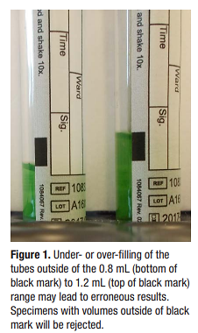OhioHealth Laboratory Services

QuantiFERON-TB Gold PLUS Collection Instructions

1. All collection tubes need to be at room temperature (17⁰-27⁰C) at the time of draw.
2. Collect 1 mL of blood into each of the 4 tubes (Gray, Green, Yellow, Purple) provided in the kit.

* If butterfly needle is used, first collect other required tubes, or use a “purge” tube to remove the air and then proceed with collecting the QTB tubes.
* Tubes fill slowly.
* When the tube is upright, blood must be within the small black line on the label. See figure 1.
* **Specimen volumes outside of black mark will be rejected.**

1. Immediately shake each tube 10 times firmly enough to ensure the entire inner surface of the tube is coated with blood. See figure 2.

* **Do not vigorously shake the tubes.** Overly energetic shaking could lead

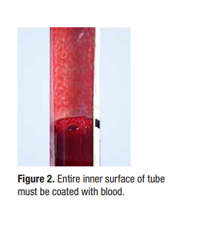to gel disruption and cause aberrant results.

1. Label all tubes appropriately making sure the correct color label is on the appropriate

colored tube, the QuantiFERON colored band and entire specimen volume is visible.

* Write collection time on ALL tubes.

1. Maintain tubes at room temp and transport to RMH Special Testing.

* **Tubes must reach RMH Special Testing within 12 hours of collection time**

**or samples may be rejected.**

OhioHealth Laboratory Services

QuantiFERON-TB Gold PLUS Collection Instructions

1. All collection tubes need to be at room temperature (17⁰-27⁰C) at the time of draw.
2. Collect 1 mL of blood into each of the 4 tubes (Gray, Green, Yellow, Purple) provided in the kit.

* If butterfly needle is used, first collect other required tubes, or use a “purge” tube to remove the air and then proceed with collecting the QTB tubes.
* Tubes fill slowly.
* When the tube is upright, blood must be within the small black line on the label. See figure 1.
* **Specimen volumes outside of black mark will be rejected.**

1. Immediately shake each tube 10 times firmly enough to ensure the entire inner surface of the tube is coated with blood. See figure 2.

* **Do not vigorously shake the tubes.** Overly energetic shaking could lead

to gel disruption and cause aberrant results.

1. Label all tubes appropriately making sure the correct color label is on the appropriate

colored tube, the QuantiFERON colored band and entire specimen volume is visible.

* Write collection time on ALL tubes.

1. Maintain tubes at room temp and transport to RMH Special Testing.

* **Tubes must reach RMH Special Testing within 12 hours of collection time**

**or samples may be rejected.**